**Assignment-1**

Connect and disconnect with login Access

* What happens when you login a non-existent users or username?

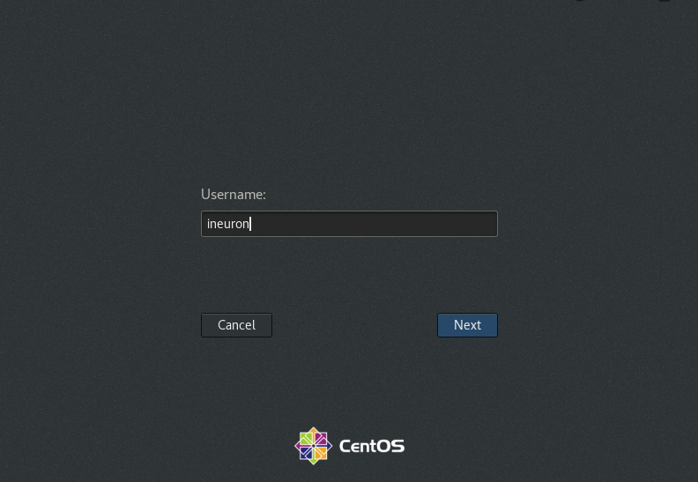

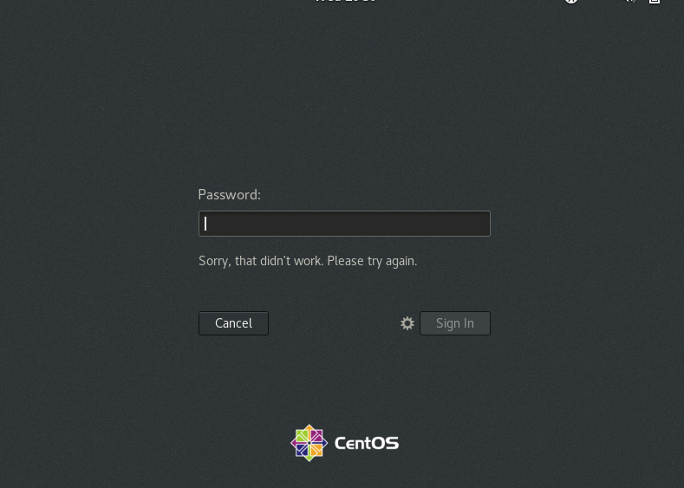

It would not allow any non-existent users or username to login until and unless they are registered or created account on to the OS of this machine.

**Assignment-2**

Password changing

* Login into your account and then change password?
  + Change your password into **IneuR0n#42** and hit the **Enter** key

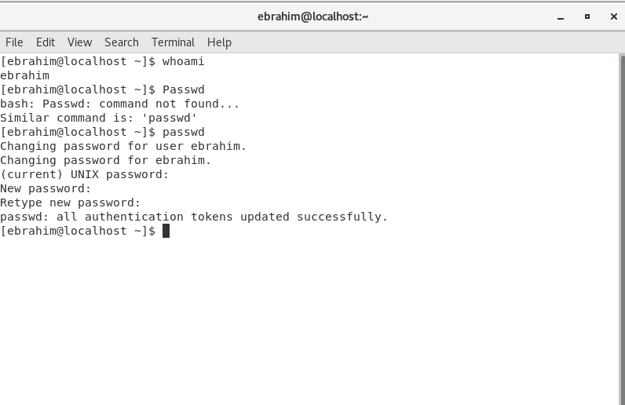

Password was changed successfully to **IneuR0n#42**  
As the password matched the criteria (Length, uppercase, lowercase, number and a special character)

* + Try again to change password but use like password ***1234*** or ***abcd***

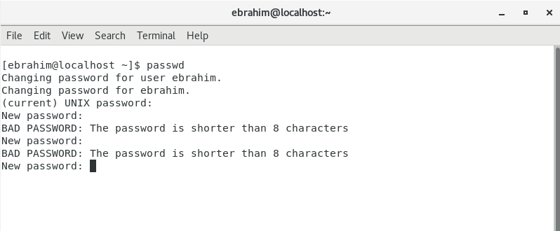

Password failed as it didn’t meet the criteria of length of minimum 8 characters

* + Try again to change password but now don’t use any password just hit **Enter** key

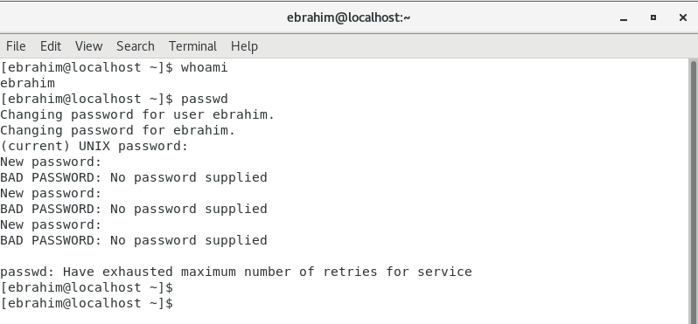

Since no password was supplied. Automatically after maximum retries of 3 attempts the cmd was timed out to new line.

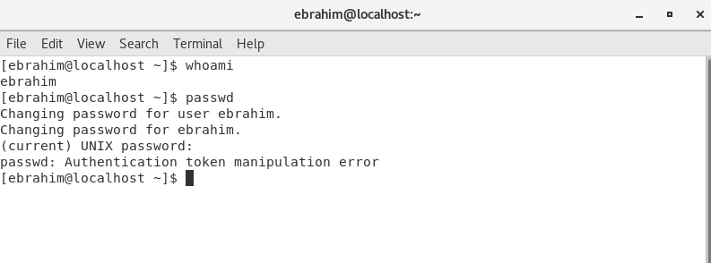

In this case no current password was given, due to which cursor came out with an error stating it didn’t meet the authentication requirements.

**Assignment-3**

Working with Directories

* Enter the command **cd /** and then **ls** and then hit **Enter** key

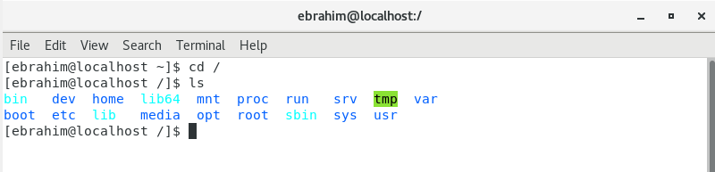

In the above screenshot, we are navigating from current directory into the root directory (‘/’)

With ls command we have listed out all the directories under /

* Enter the command now **cd /home** and then hit **Enter** key

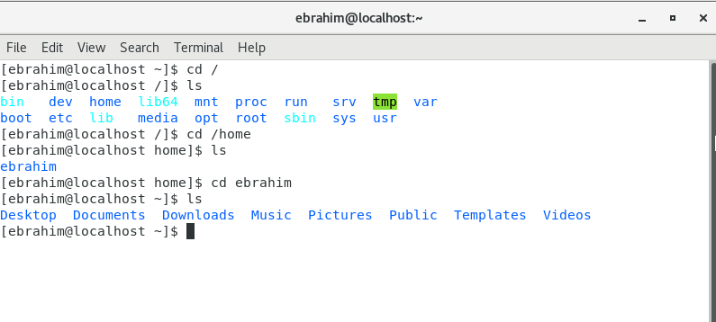

/home directory is a directory where user specific files are maintained dedicatedly, it is used to manage user’s files and privacy.

* Enter **cd ..** and hit **Enter** key [ *Note: here we have space after cd then use double dot*]

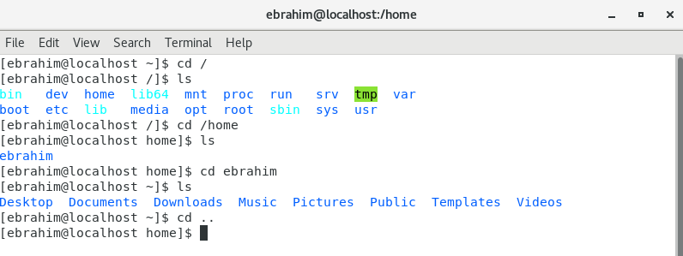

We were inside user(ebrahim) directory, on executing cd .. we are navigated into /home directory.

cd .. simply navigates to the directory above the present or current directory.

* Now enter **cd /var/www/html** and then type **cd** and hit **Enter** key

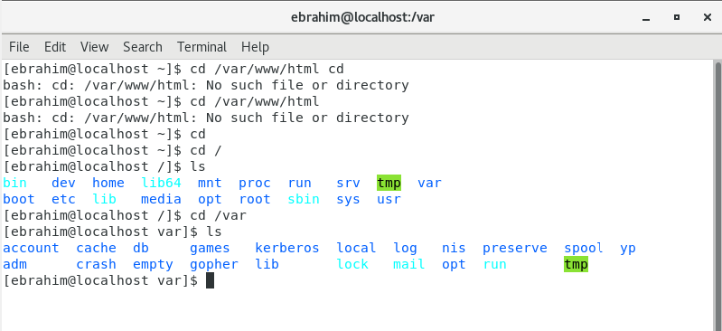

On executing **cd /var/www/html –** There’s no such file or directory.  
On verifying through cd -> /var and ls (There is no www file or directory under /var)

* Now type **cd /root** and then hit **Enter** key

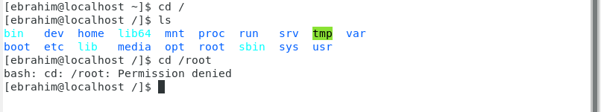

We cannot navigate into /root as this root user’s directory from current directory. As we do not have the permissions. It can only be accessed by root user credentials or sudo command to view /root directory.

**Assignment-4**

Working with File Listing

* Go to **cd /etc** and type **ls**

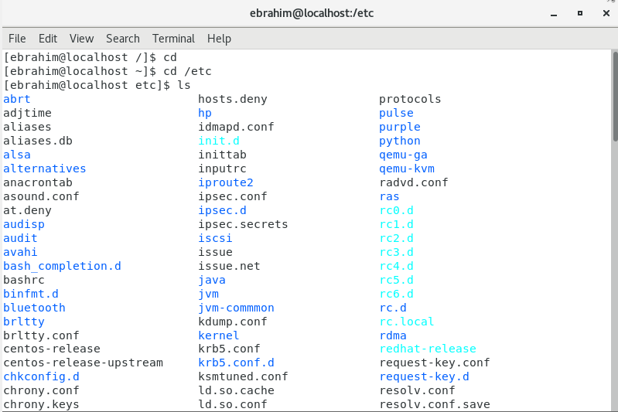

Most of the files ending with **.conf** were found here. I strongly believe that /etc is a directory consisting of all configuration files and directories.

* Then type **ls -al** and hit **Enter** key

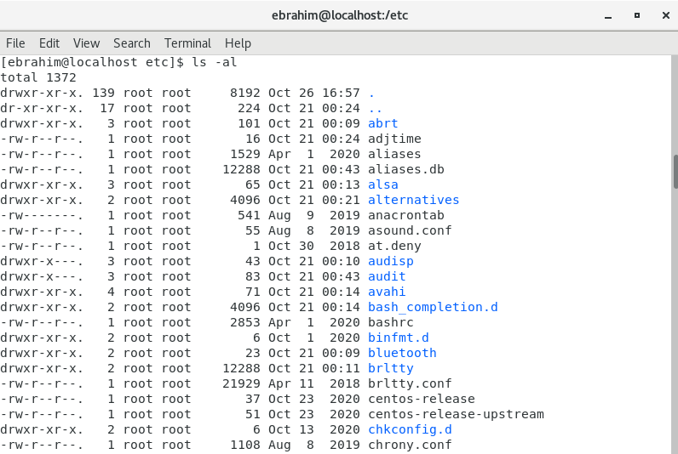

Through this command I could view all the files and directories including the hidden one’s with detailed information about each file like it’s permissions, file size, owner of the file, modified date and time and the file or directory name.

* Then use **ls -i** and hit **Enter** key

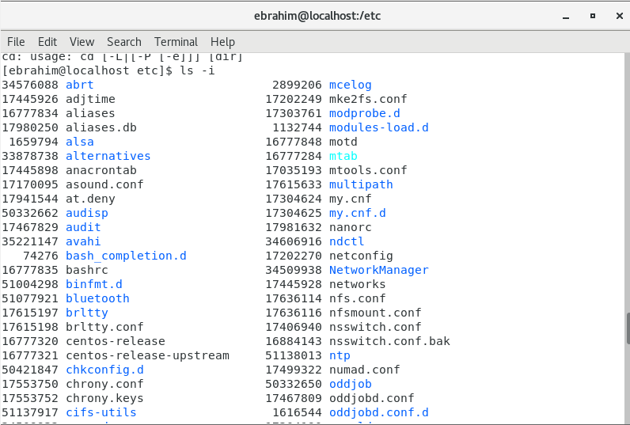

Now **ls -i** shows some different output when compared to previous one’s. It lists out all the files and directories with some numbers allocated to it right before it’s name.

* Then use **ls –help** and see other options about **ls** command

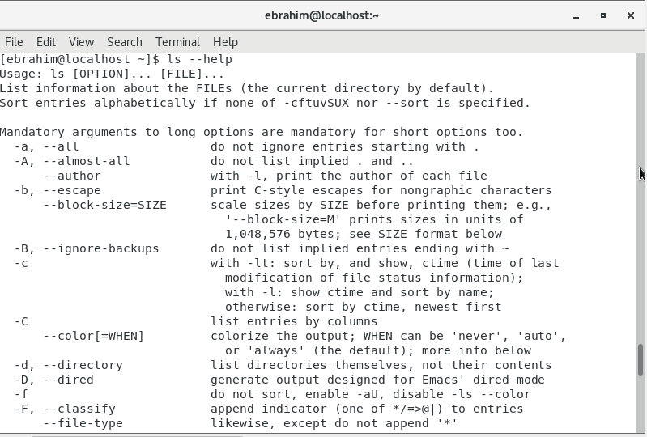

With the help this command, I could find that ls -i listed out the files, indexing an inode number to each file.

**Assignment-5**

Know where you are and where you working

*Here we use* ***pwd, cd and ls*** *as combine task to understand where you working on terminal and how you can switch from one directory to another one.*

* Open terminal after restart the linux
  + Check which location you working, type **pwd** and take screenshot
* Now use **cd /var** and hit **Enter** key
  + Do **ls,** and see what output comes, give screenshot?

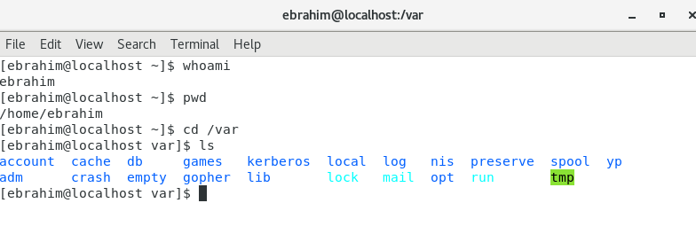

I am currently working as **user- ebrahim** which is under the /home directory

On using **cd /var** and **ls -** I could view the spool, log and temporary files under variable directory (/var)

* Do explore other help options of each command to learn more other things we can do with these commands

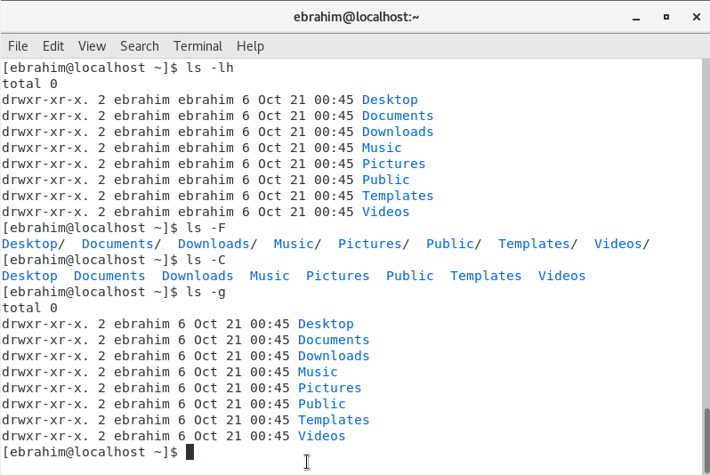

**Live Class Assignment 1 :-** Install all the dependencies for making CentOS full screen

1. Proceed to Insert Guest Addition CD image via VirtualBox

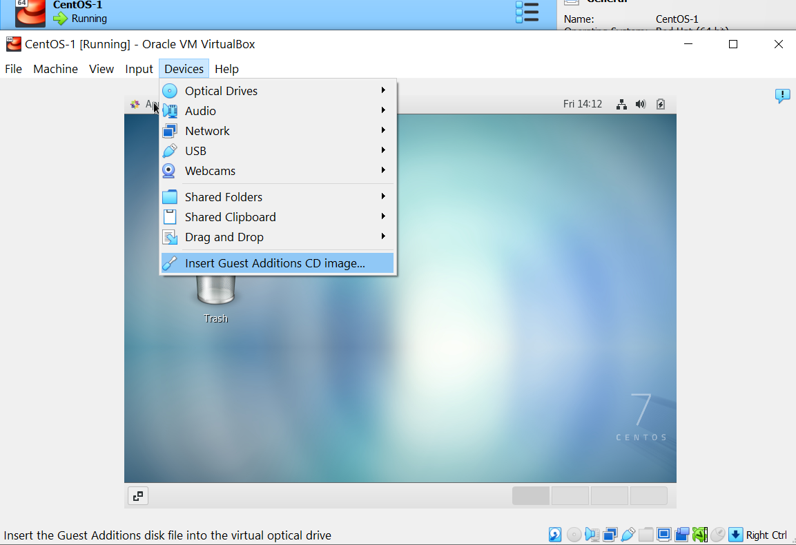

1. Proceed to run the software of Guest Addition

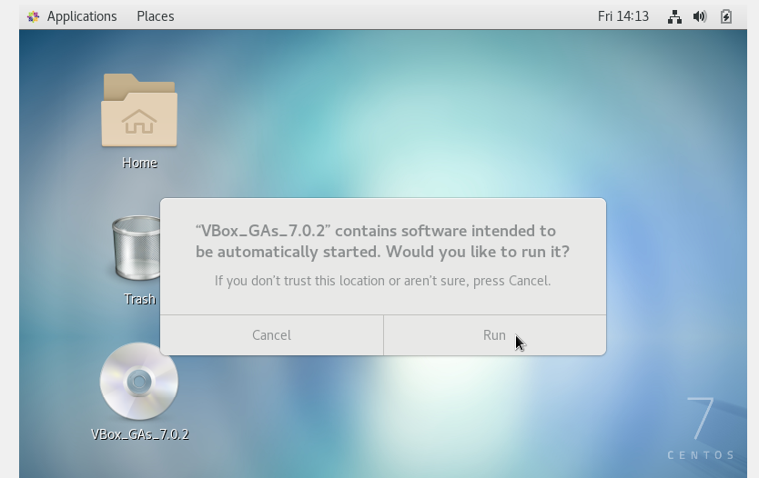

1. Installation would begin. After which Kernel header not found and vboxguest failed error popped up.

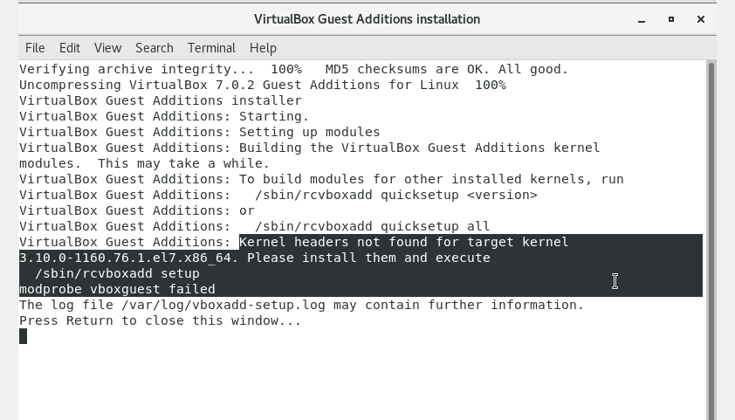

1. Now power off the VM to make some changes in the settings.

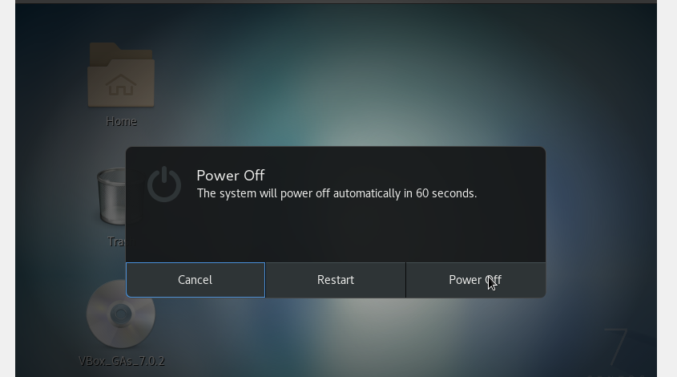

1. Go to Storage settings on the VirtualBox for this VM

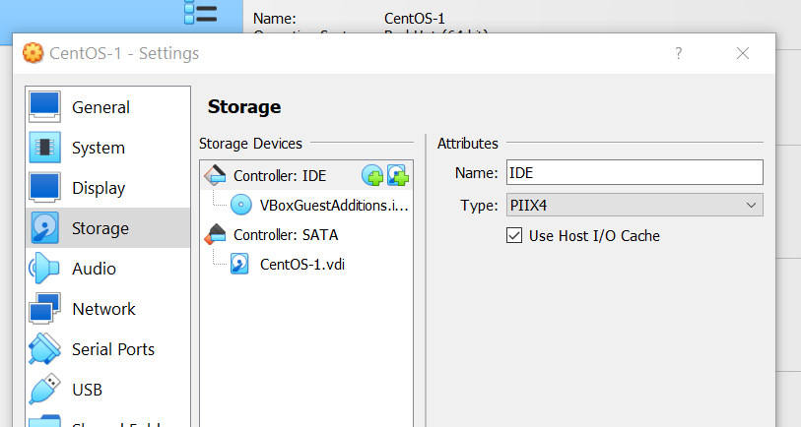

1. In the Controller: IDE, add another image of **CentOS** and make the Optical drive as **IDE Secondary Device 1**. Let the **VBoxGuestAddition** iso be on **IDE Primary Device 0**

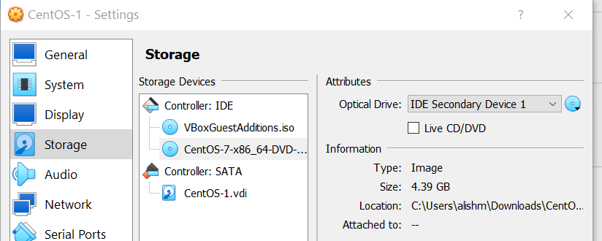

1. Now Power On the VM to begin resolving the pending dependencies

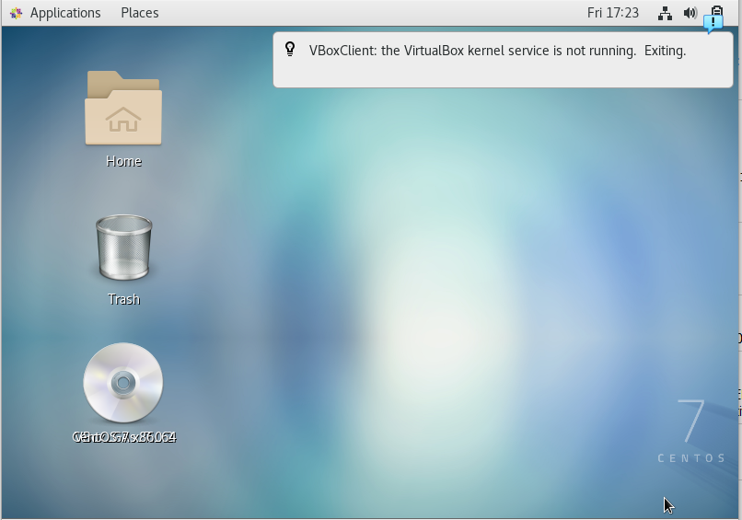

1. With the root access, located the CentOS iso file which was manually added through the Storage settings

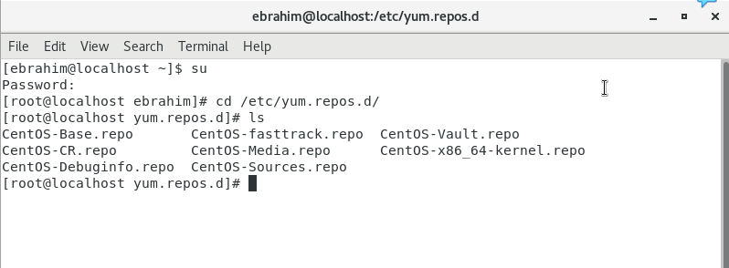

1. Now open the located CentOS iso file in terminal

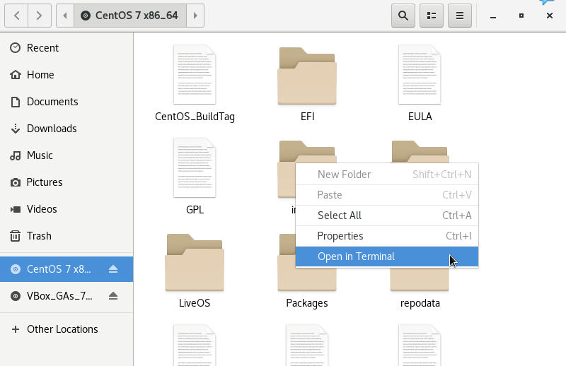

1. Through ‘pwd’ find the path where iso is located and copy the path name

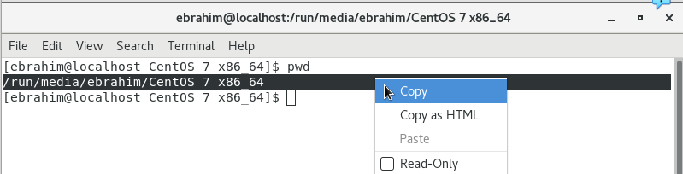

1. Go back to the previous terminal and hit on to ‘vi dvd.repo’

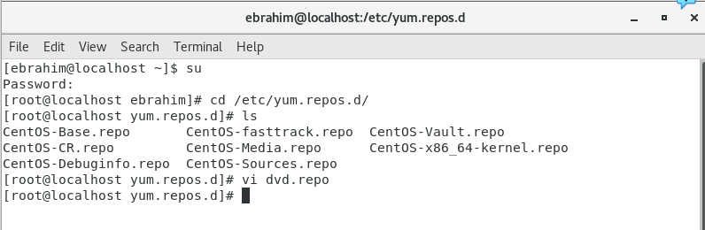

1. Enter the vi editor insert mode and hit onto below cmds by pasting the path of CentOS iso, save it and check the status.

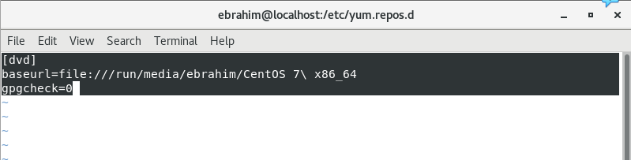

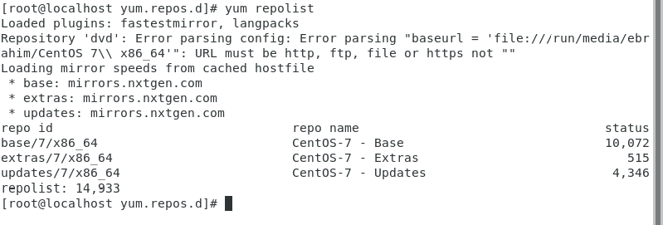

1. Now we begin to resolve the kernel header errors

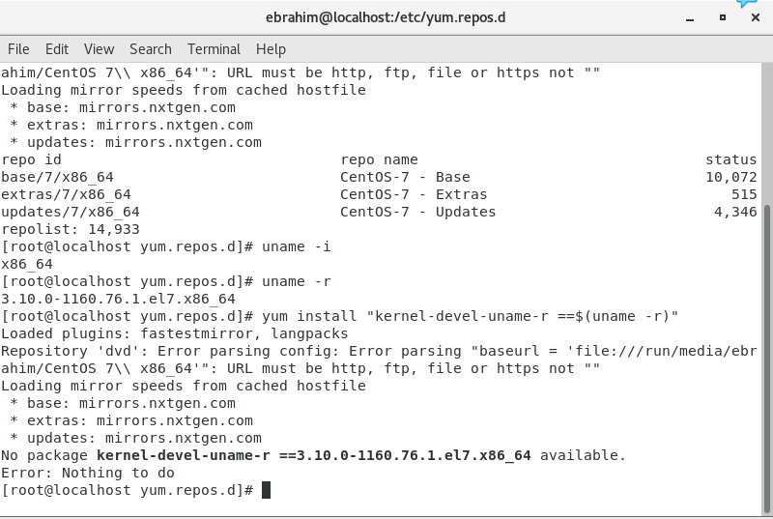

1. We try to run VBox Guest Addition file and still see the same errors

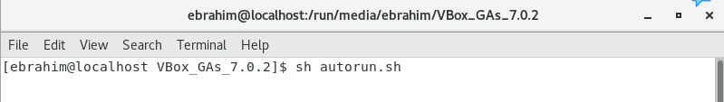

1. Now we install the kernel devel package

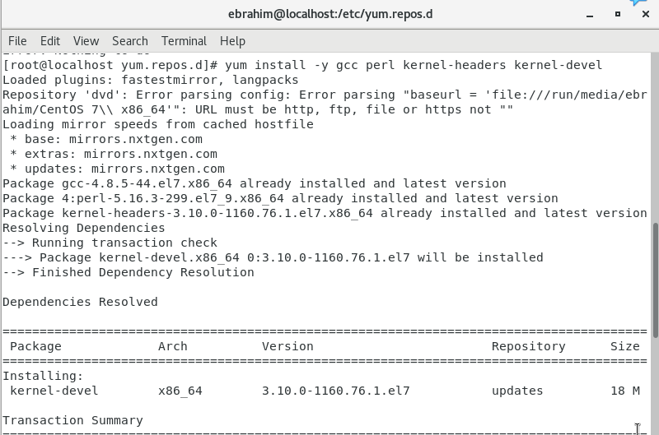

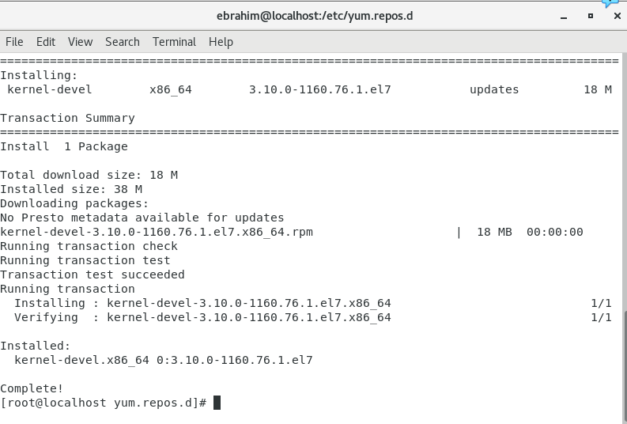

1. Since we do not see any errors now, we are good to proceed further by restarting the VM.

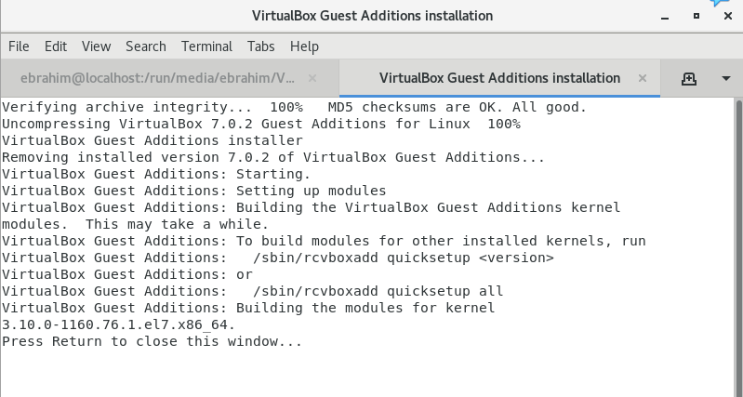

1. After a clean restart of VM, we could see that the dependencies are completely resolved, and CentOS is visible as **Full screen**.

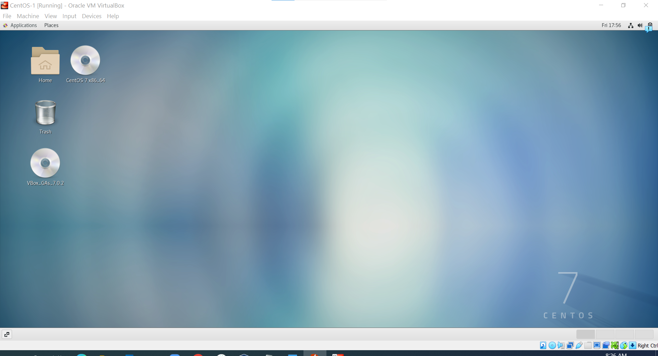

**Assignemnt 2:-** Please update you CentOS machine

1. Performed Yum updates to check the packages and installed the latest version of OS on my machine.

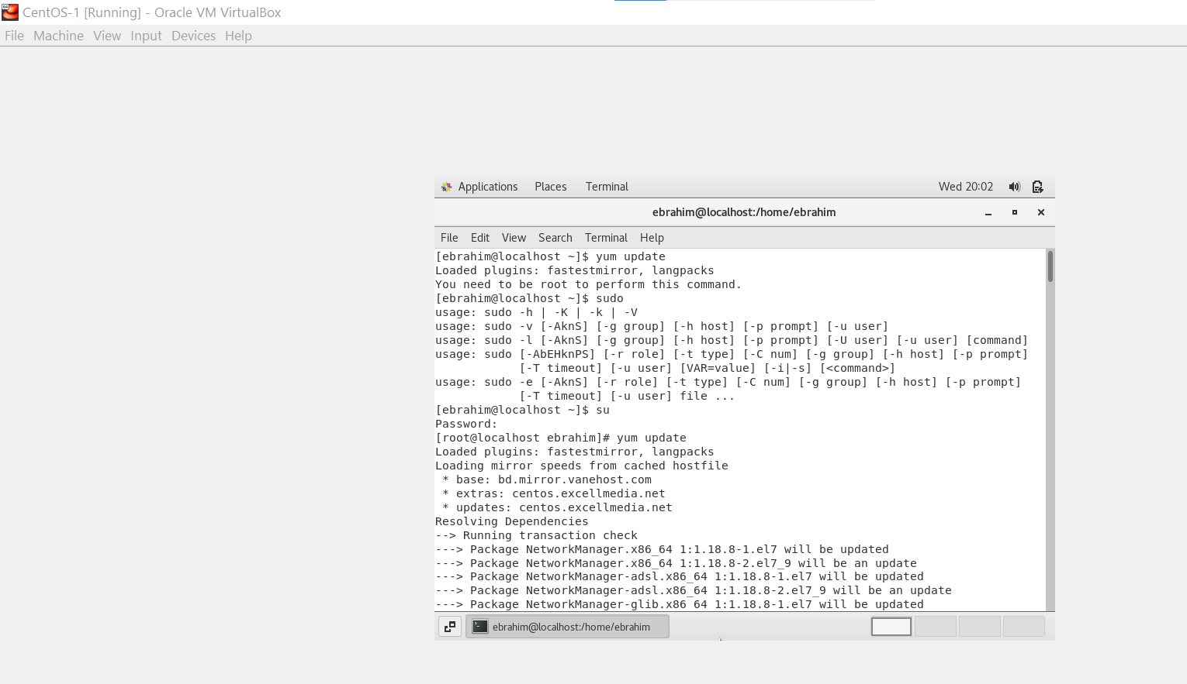

1. As per the Post-checks it is now running on a latest version.

